Results of surgical treatment of vascular graft infections with candida - an argument for empiric treatment with antifungals perioperatively?

Dries Dorpmans

Abstract:
Objective:
Vascular graft infection (VGI) is associated with high morbidity and mortality rates. The first choice treatment consists of explantation of the graft, resection of the inflammatory tissues, in situ revascularization and empiric broad spectrum antibiotics that are secondarily downgraded according to microbiological results. These empiric antibiotics do not cover candida. We retrospectively studied the outcome of candida compared to non-candida VGI and assessed whether these results could justify the addition of antifungals to the empiric antibiotics in the early postoperative period.

Methods:
All patients treated for infected aorto(ilio)femoral graft with excision and in situ reconstruction at the vascular department of University Hospitals Leuven between January 2010 and 2017 (n=56) were studied retrospectively. Patients were allocated to the candida group (n=10) or non-candida group (n=46) according to the germs grown in deep cultures.

Results:
All-cause mortality was significantly higher in the candida group (90%) compared to the non-candida group. All-cause 30-day mortality was 40% and 13% for both groups respectively (p=0.066). At 5 years this was 90% and 46% respectively (p=0.014). The mean length of in hospital stay was 47±34 days in the candida group and 34±21 days in non-candida infected VGI’s (p=0.341). Mean length of stay in the ICU was 15±13 days and 8±13 days respectively (p=0.206). In the candida group 6 patients (60%) had to be revised in the operating room due to bleeding, compared to 5 patients (11%) in the non-candida group (p=0.002). Two patients (20%) and five patients (11%) had to be readmitted to the ICU, respectively.
Conclusion:
Survival of candida related VGI is significantly worse, especially in the first 5 postoperative months. Few contra-indications for association of antifungals to the empiric treatment of vascular graft infections exist. This could justify the addition of antifungals to the early empiric postoperative antibiotic cocktail. A cost-benefit analysis could be useful to evaluate the yield.

Introduction
Vascular graft infection (VGI) is a rare but very deleterious complication in reconstructive vascular surgery. The overall incidence is 1-6% and only 1-3% in aorto(ilio)femoral grafts¹. But left untreated, VGI is associated with morbidity and mortality rates of 30-60% with limb amputation rates between 10% and 40%^{2–4}. The most feared complications following VGI are organ failure, amputation and death. The timeframe between primary surgery and clinical manifestation of graft infection shows large variation. The clinical presentation is often non-specific.
Treatment consists of explantation of the graft, resection of the inflammatory tissues and in situ or extra-anatomic revascularization. In situ reconstructions are preferred because of better long-term patencies⁵. Reconstruction with autologous deep vein is the preferred option because of relative resistance to graft infection and lower mortality rates^{1,2,4}.
Usually empiric broad-spectrum antibiotics are administered after deep cultures are prelevated, to cover the main causative pathogens of VGI: staphylococci, gram-positive cocci (enterococci, streptococci) and gram-negative rods (E. coli, pseudomonas). These empiric antibiotics are secondarily downgraded according to microbiological results. Only in rare cases, and more frequent in late onset infections (>4 months), fungal organisms are identified as the source of the infection. These fungi are however not covered in the standard empiric regimen³. In the literature the prevalence of candida varies from 3 to 37%. Candidiasis has been recorded more frequently in the presence of aortoenteric (AE) fistulae which is related to more reinfection, re-intervention and worse outcome⁶⁻⁸.
We retrospectively studied the outcome of candida compared to non-candida VGI and assessed whether these results could justify the addition of antifungals to the empiric antibiotics in the early postoperative period.

Patients and methods
Population
All patients treated for infected aorto(ilio)femoral graft with excision and in situ reconstruction at the vascular department of University Hospitals Leuven between January 2010 and 2017 were studied retrospectively. Patients were allocated to the candida or non-candida group according to the germs grown in the deep cultures.

Definitions
We defined a graft infection as the presence of purulent fluid directly communicating with the graft with or without positive cultures or an exposed graft (Szilagyi’s classification grade III-IV-V).
Empirical treatment was started immediately after microbiological intraoperative samples were taken in patients without severe sepsis and consisted of a combination of broad-spectrum beta-lactams (i.e. piperacillin-tazobactam) and anti-methicillin-resistant S. aureus agents (i.e. vancomycin) ± aminoglycosides. No antibiotic prophylaxis was given before surgical revision.
The candida group was defined as VGI in which candida was grown out of the excised graft or the perivascular liquid. Candida grown from urine samples was excluded because of it being a frequent pathogen in the urogenital tract without clinical implications for the vascular graft. Candida grown from abdominal drains was excluded because surgical patients at the ICU treated with broad spectrum antibiotics are frequently colonized. The non-candida group was composed of VGI in which graft cultures grew other microorganisms or in which cultures remained sterile but with a radiological and clinically confirmed graft infection.
The primary endpoint of the study was patient survival, evaluated at day 30 and during 5 year of follow-up (with the Kaplan-Meier method). The secondary endpoints were length of hospital stay, length of ICU stay, return to ICU and revision for bleeding.

Statistical analysis
Data on demographic characteristics, comorbidities, clinical presentation, operative data and mortality were collected. Normality was checked using a Shapiro-Wilk test. Continuous variables, expressed as mean values (±SD) were compared using t-test or the Mann-Whitney U test, as appropriate. Categorical variables, expressed as percentages, were compared using the Chi-square or Fisher’s exact test. Kaplan Meier survival analysis was used to estimate survival and the groups were compared using the log rank, Breslow and Tarone-Ware tests. Statistical software SPSS was used for analyses. A p-value <0.05 was considered statistically significant.

Results
Between 2000 and 2017, 56 patients were treated for infection of aorto(ilio)femoral graft with excision and in situ reconstruction. In 10 patients (18%) candida was grown in the cultures, while in 46 patients (82%) other microorganisms were grown or cultures remained sterile.

Demographics
Main patient characteristics are summarized in Table 1. Mean age was 67±9 years with a range of 47 to 85 years. Men comprised the majority of patients (82%). No significant differences between both groups regarding basic demographic characteristics were found.
Smoking, hypertension, coronary disease, renal insufficiency, COPD, diabetes mellitus and previous surgery in the abdomen and groin have been defined as risk factors for VGI. None of these factors showed significant difference between both groups. The mean preoperative ASA score for the candida group was slightly higher than the non-candida group, 3.4 and 3 respectively (p=0.057). (Table 1)

Clinical presentation
Wound discharge was more frequent in the non-candida group (26%) compared to the candida group (0%), although statistically not significant (p= 0.070). Other symptoms like fever, erythema, ischaemia and bleeding were not statistically significant different between both groups. Leucocytosis (57%) and elevated CRP (80%) were highly prevalent on presentation of VGI. In 53 cases (95%) imaging was conducted to confirm the diagnosis of graft infection. (Table 2)

Surgical data
In the non-candida group, 80% of infected grafts were aortofemoral grafts while this was only 40% in the candida group (p=0.016). Mean operative time was 6.9±2.5 hours for the candida group and 7.7±2.1 hours for the non-candida group. A higher incidence of associated AE fistula was found in the candida group (60%) compared to the non-candida group 28% (p=0.063). Reconstruction with autologous deep vein was the preferred method in both groups. (Table 3)

Outcome
All-cause mortality was significantly higher in the candida group compared to the non-candida group. All-cause 30-day mortality was 40% and 13% for both groups respectively (p=0.066). At 5 years this was 90% and 46% respectively (p=0.014). The mean length of hospital stay was 47±34 days in the candida group and 34±21 days in non-candida infected VGI’s (p=0.341). Mean length of stay in the ICU was 15±13 days and 8±13 days respectively (p=0.206). In the candida group 6 patients (60%) had to be revised in the operating room due to bleeding, compared to 5 patients (11%) in the non-candida group (p=000.2). Two patients (20%) and five patients (11%) had to be readmitted to the ICU, respectively. (Table 4)

The postoperative survival rates are illustrated as a Kaplan-Meier curve in Figure 1. In both groups, most deaths occurred in the first 5 months postoperatively.
Discussion
VGI is a feared complication after vascular reconstructive surgery. Although rare, it is associated with high morbidity and mortality rates.
CT scan is the first line diagnostic modality with an overall sensitivity of 94% and a specificity of 85% for high-grade infections⁹. Microbiological samples may support the diagnosis.
The surgical treatment of VGI is challenging and involves a major intervention in patients who are often critically ill. The basic principles of surgical treatment involve debridement of infected periprosthetic tissues, possible excision of the infected graft and secondary revascularization.
Currently available treatments for VGI can be categorized as graft removal with extra-anatomic bypass, graft removal with in situ graft replacement, or attempted (partial or complete) graft preservation. There is no single approach that applies to all patients with aortic graft infections; rather, the choice of reconstruction depends on the specific patient comorbidities, extent and virulence of the infection, and severity of the vascular disease.
We report the outcome of 56 patients treated for infected aorto(ilio)femoral grafts with excision and in situ reconstruction. Our study showed a higher overall mortality in candida VGI when compared to non-candida infections. Regarding secondary end points, we observed considerable higher revision rates because of bleeding in the candida group.
Chung et al¹⁰ reported infection with Candida glabrata to be one of the strongest predictors of mortality in their series. They also found that recurrent infection after in situ reconstruction with autologous vein is rare, only occurring in cases of overwhelming sepsis, or with infection with a virulent species of organism, such as Candida, Pseudomonas, or polymicrobial infection.
Although not statistically significant, we observed a higher portion of AE fistulae in the candida group. The same correlation has been made in the literature, which states that in two-thirds of secondary AE fistulae, candida species are cultured. ⁶ ⁻⁸. So although not pathognomonic, presence of an AE fistula could be an indication to empirically treat these patients with antifungals until cultures are known.
Fluconazole is the preferred first-line agent for systemic candida infections in non-neutropenic patients. Most frequently recorded side-effects are gastrointestinal discomfort (nausea, vomiting, diarrhoea), rash and elevated liver enzymes. For this reason, few contraindications exist for administering systemic antifungals perioperatively as part of standard empiric treatment of VGI¹¹.
A cost-benefit analysis could be useful to evaluate the yield.
Our study suffers several limitations. The retrospective design and the limited number of patients in both groups reduce the statistical power of the results and may introduce bias. University Hospitals Leuven is a referral centre and it is not uncommon for patients to return to their referring centres after initial treatment. For this reason, we lack certain data of follow-up regarding post-operative complications and quality of life. Finally, VGI is known as often being a polymicrobial infection. In our study we solely assessed the presence of candida and other microorganisms were not taken into account.

Conclusion
Candida infected aorto(ilio)femoral grafts are more frequently found than suggested by microbiological data in the literature. Presence of an AE fistula could be an indication for a candida contaminated graft infection. Our data show worse survival rates and a higher revision rate when candida is the causative micro-organism. Few contra-indications for association of antifungals to the empiric treatment of vascular graft infections exist. This could justify the addition of antifungals to the early empiric postoperative antibiotic cocktail. A cost-benefit analysis could be useful to evaluate the yield.

References

1. O’Connor S, Andrew P, Batt M, Becquemin JP. A systematic review and meta-analysis of treatments for aortic graft infection. J Vasc Surg. 2006 Jul;44(1):38–45.e8.
2. Hicks RCJ, Greenhalgh RM. The pathogenesis of vascular graft infection. Eur J Vasc Endovasc Surg. 1997 Dec;14:5–9.
3. Hasanadka R, Seabrook GR, Edmiston CE. Vascular Graft Infections. In: Infectious Diseases in Critical Care. Berlin, Heidelberg: Springer Berlin Heidelberg; 2007. p. 531–41.
4. Dorweiler B, Neufang A, Chaban R, Reinstadler J, Duenschede F, Vahl C-F. Use and durability of femoral vein for autologous reconstruction with infection of the aortoiliofemoral axis. J Vasc Surg. 2014 Mar;59(3):675–83.
5. Erb S, Sidler JA, Elzi L, Gurke L, Battegay M, Widmer AF, et al. Surgical and Antimicrobial Treatment of Prosthetic Vascular Graft Infections at Different Surgical Sites: A Retrospective Study of Treatment Outcomes. PLoS One. 2014 Nov 13;9(11):e112947.
6. Ali AT, Modrall JG, Hocking J, Valentine RJ, Spencer H, Eidt JF, et al. Long-term results of the treatment of aortic graft infection by in situ replacement with femoral popliteal vein grafts. J Vasc Surg. 2009 Jul;50(1):30–9.
7. Heinola I, Kantonen I, Jaroma M, Albäck A, Vikatmaa P, Aho P, et al. Editor’s Choice – Treatment of Aortic Prosthesis Infections by Graft Removal and In Situ Replacement with Autologous Femoral Veins and Fascial Strengthening. Eur J Vasc Endovasc Surg. 2016 Feb;51(2):232–9.
8. Chung J. Management of Aortoenteric Fistula. Adv Surg. 2018 Sep;52(1):155-177. doi: 10.1016/j.yasu.2018.03.007. Epub 2018 Apr 26.
9. Orton DF1, LeVeen RF, Saigh JA, Culp WC, Fidler JL, Lynch TJ, Goertzen TC, McCowan TC. Aortic prosthetic graft infections: radiologic manifestations and implications for management. Radiographics. 2000 Jul-Aug;20(4):977-93.
10. Chung J, Clagett GP. Neoaortoiliac System (NAIS) procedure for the treatment of the infected aortic graft. Semin Vasc Surg. 2011 Dec;24(4):220–6.
11. Charlier C, Hart E, Lefort A, Ribaud P, Dromer F, Denning DW, et al. Fluconazole for the management of invasive candidiasis: Where do we stand after 15 years? J Antimicrob Chemother. 2006;57(3):384–410.

TABLES

Table 1. Patient demographics and comorbidities

 | Non-candida VGI  (n=46) | Candida VGI  (n=10) | p-value
Demographics
Age, y, mean ± SD | 68 ± 9.4 | 66.5 ± 6.4 | 0.222
Sex, M/F, n | 35/11 | 10/0 | 0.114
BMI, mean ± SD | 24.3 ± 4.2 | 23.9 ± 3.9 | 0.971
Comorbidities
ASA score, mean ± SD | 2.96 ± 0.8 | 3.4 ± 0.5 | 0.057
Smoking, n (%) | 26 (57) | 6 (60) | 0.564
Hypertension, n (%) | 26 (57) | 6 (60) | 0.564
Coronary disease, n (%) | 14 (30) | 4 (40) | 0.405
Renal insufficiency, n (%) | 8 (17) | 1 (10) | 0.490
COPD, n (%) | 8 (17) | 3 (30) | 0.304
Diabetes mellitus, n (%) | 5 (11) | 1 (10) | 0.711
Previous abdominal surgery, n (%) | 1.2 (0.5) | 1.2 (1.0) | 0.265
Previous groin surgery, n (%) | 2.3 (1.8) | 3.6 (4.6) | 0.698

Table 2. Symptoms at the time of presentation, laboratory findings and additional radiologic imaging

 | Candida VGI  (n=10) | Non-candida VGI  (n=46) | p-value
Fever, n (%) | 5 (50) | 11 (24) | 0.105
Erythema, n (%) | 1 (10) | 6 (13) | 0.635
Wound discharge, n (%) | 0 (0) | 12 (26) | 0.070
Ischemia, n (%) | 1 (10) | 7 (15) | 0.560
Bleeding, n (%) | 2 (20) | 4 (9) | 0.289
Leukocytosis, n (%) | 6 (60) | 26 (56) | 0.564
Elevated CRP, n (%) | 10 (100) | 39 (85) | 0.231
Radiologic diagnosis, n (%) | 10 (100) | 43 (94) | 0.548

Table 3. Type of infected graft, type and material for reconstruction and operative data

 | Candida VGI  (n=10) | Non-candida VGI  (n=46) | p-value
Type of infected graft
Aortofemoral graft, n (%) | 4 (40) | 37 (80) | 0.016
Aortic tube graft, n (%) | 3 (30) | 4 (9) | 0.099
Aortoiliac graft, n (%) | 3 (30) | 5 (11) | 0.143
Reconstruction
Aortofemoral graft, n (%) | 3 (30) | 29 (63) | 0.060
Aortic tube graft, n (%) | 1 (10) | 0 (0) | 0.179
Aortoiliac graft, n (%) | 4 (40) | 10 (22) | 0.206
Extra-anatomical graft, n (%) | 2 (20) | 8 (17) | 0.576
Material
Deep vein, n (%) | 7 (70) | 35 (76) | 0.482
Homograft, n (%) | 0 (0) | 3 (7) | 0.548
Prosthesis, n (%) | 2 (20) | 8 (17) | 0.576
Operative data
Mean duration of surgery , hours , mean ± SD | 6.9 (2.5) | 7.7 (2.1) | 0.988
Presence of aortoenteric fistula, n (%) | 6 (60) | 13 (28) | 0.063

Table 4. Outcome data

 | Candida VGI  (n=10) | Non-candida VGI  (n=46) | p-value
30-day mortality, n (%) | 4 (40) | 6 (13) | 0.066
Overall mortality, n (%) | 9 (90) | 21 (46) | 0.014
Hospital length of stay, mean ± SD | 47 ± 34 | 34 ± 21 | 0.341
ICU length of stay, mean ± SD | 15 ± 13 | 8 ± 10 | 0.206
Return to ICU, n (%) | 2 (20) | 5 (11) | 0.365
Revision for bleeding, n (%) | 6 (60) | 5 (11) | 0.002

FIGURES

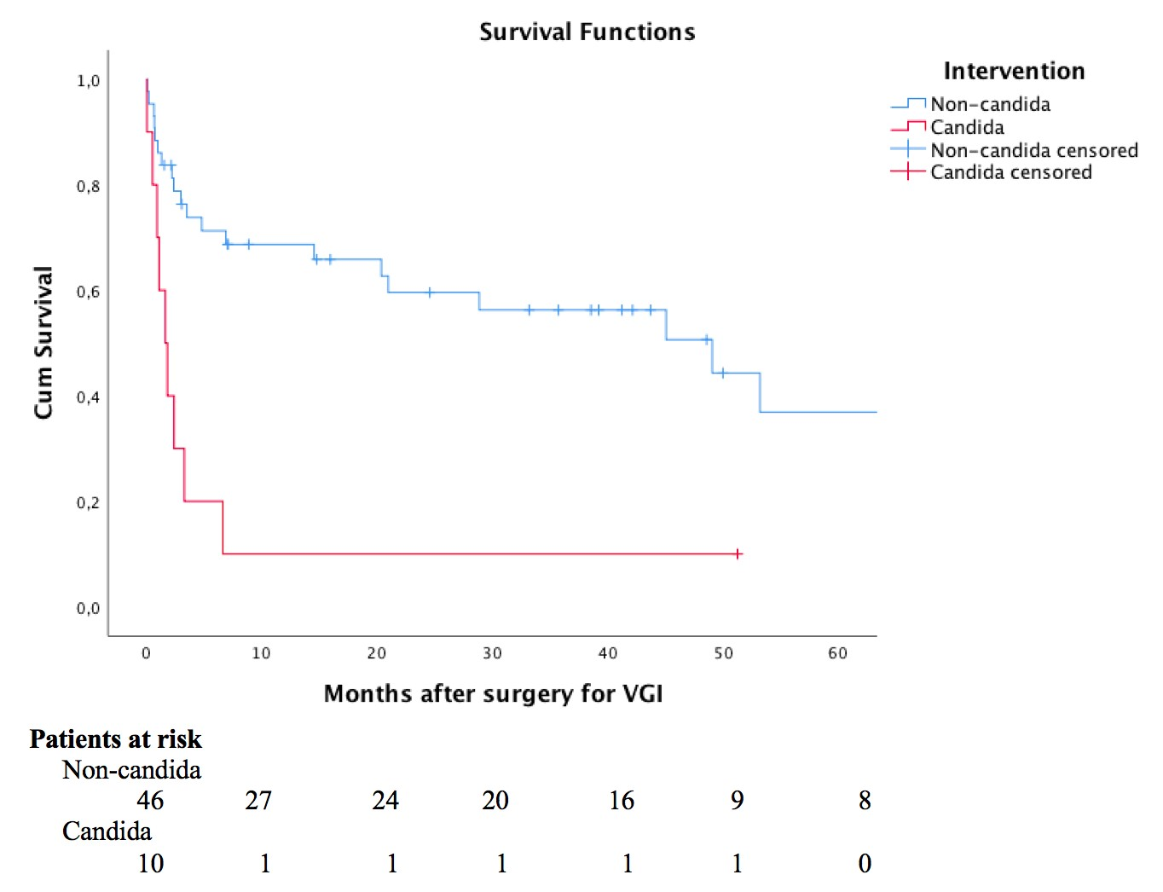

Figure 1. Kaplan-Meier life-table analysis comparing the survival rates of the candida group with the non-candida group.

